Shalfleet 'Little Explorers' Nursery and Pre-school, Shalfleet C of E Primary School, Station Road, Ningwood, Isle of Wight PO30 4NN. Telephone: 01983 760269

Shalfleet 'Little Explorers' is committed
- to provide high quality early education and childcare service which meets the diverse needs of all our children and families; throughout the local and wider community,
- to provide a safe, secure and stimulating environment that promotes equality and values diversity, in which a child can become a confident and independent learner;
- to ensure an effective partnership in which all parents/carers are made to feel welcome, valued and recognised;
- to provide a fun environment throughout the year for all children between the ages of 3 months to 11 years;
- to provide a sense of value and worth for all children and team members.

As a member of Shalfleet 'Little Explorers', your child;
- is in a safe and stimulating environment;
- is given generous care and attention, because of our high ratio of adults to children (currently 1:3 for under 2’s, 1:4 for 2 year olds, and 1:8 for 3 and 4 yr olds)
- has the chance to join with other children and adults to live, play, work and learn together;
- is supported and encouraged to develop and learn by being helped to build on what she/he already knows and can do;
- develops secure relationships which enhances learning.
- is in a setting which sees you as a partner in supporting your child to learn and develop.

The setting is open 50 weeks each year. We are closed for Bank Holidays and two weeks over Christmas. We are open 5 days each week and these are the services we provide:
Breakfast Club 08.00 – 08.30
We provide a variety of healthy breakfast options, including cereals, toast and fruit.
Full Day Care (under 3’s) 08:00 – 17.00
We have a separate Birth to Three room which provides high quality care and education for children aged from 3 months to 3 years.
Pre-School 08.30 – 15.00
We have a Foundation Stage room which provides high quality care and education for children aged 3 to 4 years.
After-School Club 15:00 – 17:00
We operate an after school club for pre-school and school aged children. We have an extensive range of activities and resources to meet children’s individual interests. At 4pm we offer the children toast / fruit and we also have facilities to reheat meals from home. We pride ourselves on having staff qualified in play works to implement both this and the holiday club provision.
Holiday Club (non-term time) 08.00 – 17.00
In each holiday club we base activities and visits on a theme, for example beach week. However we value children’s opinions and interests and we ask what they would like to do via the booking form and daily chats.
Parent, Baby & Toddler Group Wednesdays 9.15 – 11.15
This group is for parents / carers and children aged 0-4 years old. It is held in the school hall and activities include health visitor baby clinic 1st Thursday of every month, rhythm and rhyme time, mini movers, soft play and story time with the local library.

Working together for your children
Shalfleet 'Little Explorers' has a high ratio of adults to children in the setting and works within the recommended ratios set out in welfare requirements in the Early Years Foundation Stage.
This helps us to:
- give time and attention to each child
- talk with the children about their interests and activities
- help children to engage in and explore the activities and experiences we provide
- allow the children to explore and be adventurous safely.

The team who work at Shalfleet 'Little Explorers' include:

Mrs. Linda Harrop – Team Leader (Level 4 in Children’s Care, Learning and Development, Early Years Management, and Diploma in Childcare and Education Level 3

Miss Becky Lamacq – Deputy Team Leader/ Birth to Three Room Leader / Special Educational Needs Co-ordinator (Level 6 Early Years Professional Status & Degree in E. Years Care and Education )

Mrs. Nancy Taylor – Birth to Three Deputy Room Leader / Early Years Practitioner (NVQ level 3 and certificate in Children’s Care, Learning and Development & NVQ level 2 in Playworks)

Miss Charlotte Bayldon – Early Years Practitioner (Diploma in Childcare and Education Level 3 and NVQ level 2 in Playworks)

Miss. Alexx Rimmer – Early Years Practitioner (CACHE Diploma for the Children and Young People’s Workforce – Early Learning and Childcare Pathway)

Miss. Jenny Clarke – Early Years Practitioner (CACHE Level 3 Diploma in Child Care and Education)

Mrs. Tracy Haggerty - Early Years Practitioner, Foundation Stage Room Leader and Deputy Special Educational Needs Co-ordinator (NVQ level 3 in Children’s Care, Learning and Development)

Miss. Niki Beesley – Early Years Practitioner (NNEB Nursery Nursing Level 3)

Miss. Jaimee Fallows - Early Years Practitioner (Diploma for the Children and Young People’s Workforce – Early Learning and Childcare Level 4)

Mrs. Karen Ingram - Early Years Practitioner (NNEB Nursery Nursing Level 3)

Miss. Megan Sibley - Early Years Practitioner (CACHE Level 3 Diploma in Child Care and Education)

Miss Martha Obbard – Early Years Practitioner (CACHE Level 3 Diploma in Child Care and Education)

Mrs Harriet Shilton - Early Years Practitioner

Mrs. Pauline Nelson - Administrator / Fees Officer
The Early Years Foundation Stage
Our early years setting follows the statutory framework the Early Years Foundation Stage. It is a stage of children’s development from birth to the end of the first (Reception) year in school. The EYFS is based around four Themes:

A Unique Child - Every child is a competent learner from birth who can be resilient, capable, confident and self-assured (EYFS, 2012).

We, as a setting, provide a warm homely environment, ensuring a flexible routine to meet each child’s individual needs. We ensure that all children can access and have the opportunity to engage in the activities and experiences we offer through varying resources and adult support. We offer children a safe and yet challenging environment both indoors and outdoors to promote all children’s learning and development in a positive way.

We provide an environment in which all children are supported to reach their full potential. The setting actively welcomes both children and adults who have special needs and / or disabilities. The physical environment enables adults or children who are wheelchair users or have restricted mobility to access and attend the setting through ramp access, wide doorways, access to a disabled toilet and appropriate layout of both rooms. Our setting uses the key person approach and ensures all children have a primary key person and a secondary key person. This enables practitioners to develop relationships with both the child and parents/carers, to work in partnership to encourage and support all aspects of a child’s development. This therefore ensures that each child’s individual needs are met and they can access the experiences and resources offered both indoors and outdoors through adult support or adapting the environment. As part of the setting’s policy to make sure that its provision meets the needs of each individual child, we take account of any special needs which a child may have. The setting works to the requirements of the 1993 Education Act and The Special Educational Needs Code of Practice (2012). The setting’s Special Educational Needs Co-coordinators are Becky Lamacq and Tracy Haggerty .

Positive Relationships - Children learn to be strong and independent from a base of loving and secure relationships with parents and/or a key person (EYFS, 2012).

Both rooms use the key person approach where each child has a named practitioner as their primary key person and secondary key person to support the child if the primary key person is away. This enables practitioners to develop positive relationships with the child and their parents/carers to ensure that children’s individual needs are met and their interests are provided for. A key person meets the needs of each child in their care and responds sensitively to their feelings, ideas and behavior. It also supports the baby or child to become familiar with and settle into the setting, to feel confident and safe within it and encourages smooth transition between rooms.

Enabling Environments - The environment plays a key role in supporting and extending children's development and learning (EYFS, 2012).

In the Birth to Three room all the resources and equipment are easily accessible to enable the children to chose their own play opportunities encouraging independence, confidence and self-esteem and non mobile babies are offered a selection of resources to chose from based on their observed interests/preferences. As a setting we value the importance of outside play and are very fortunate to have our own garden which is separate from the main outside play area. We spend time in the garden every day (extreme weather permitting), and children have the opportunity to play with a variety of outdoors resources; slides, see-saws, trikes, cars, digging corner, chalkboard and chalks, and sand and water play. We also often carry out our activities in the outdoor environment for example welly boot painting and flying our home made kites. .
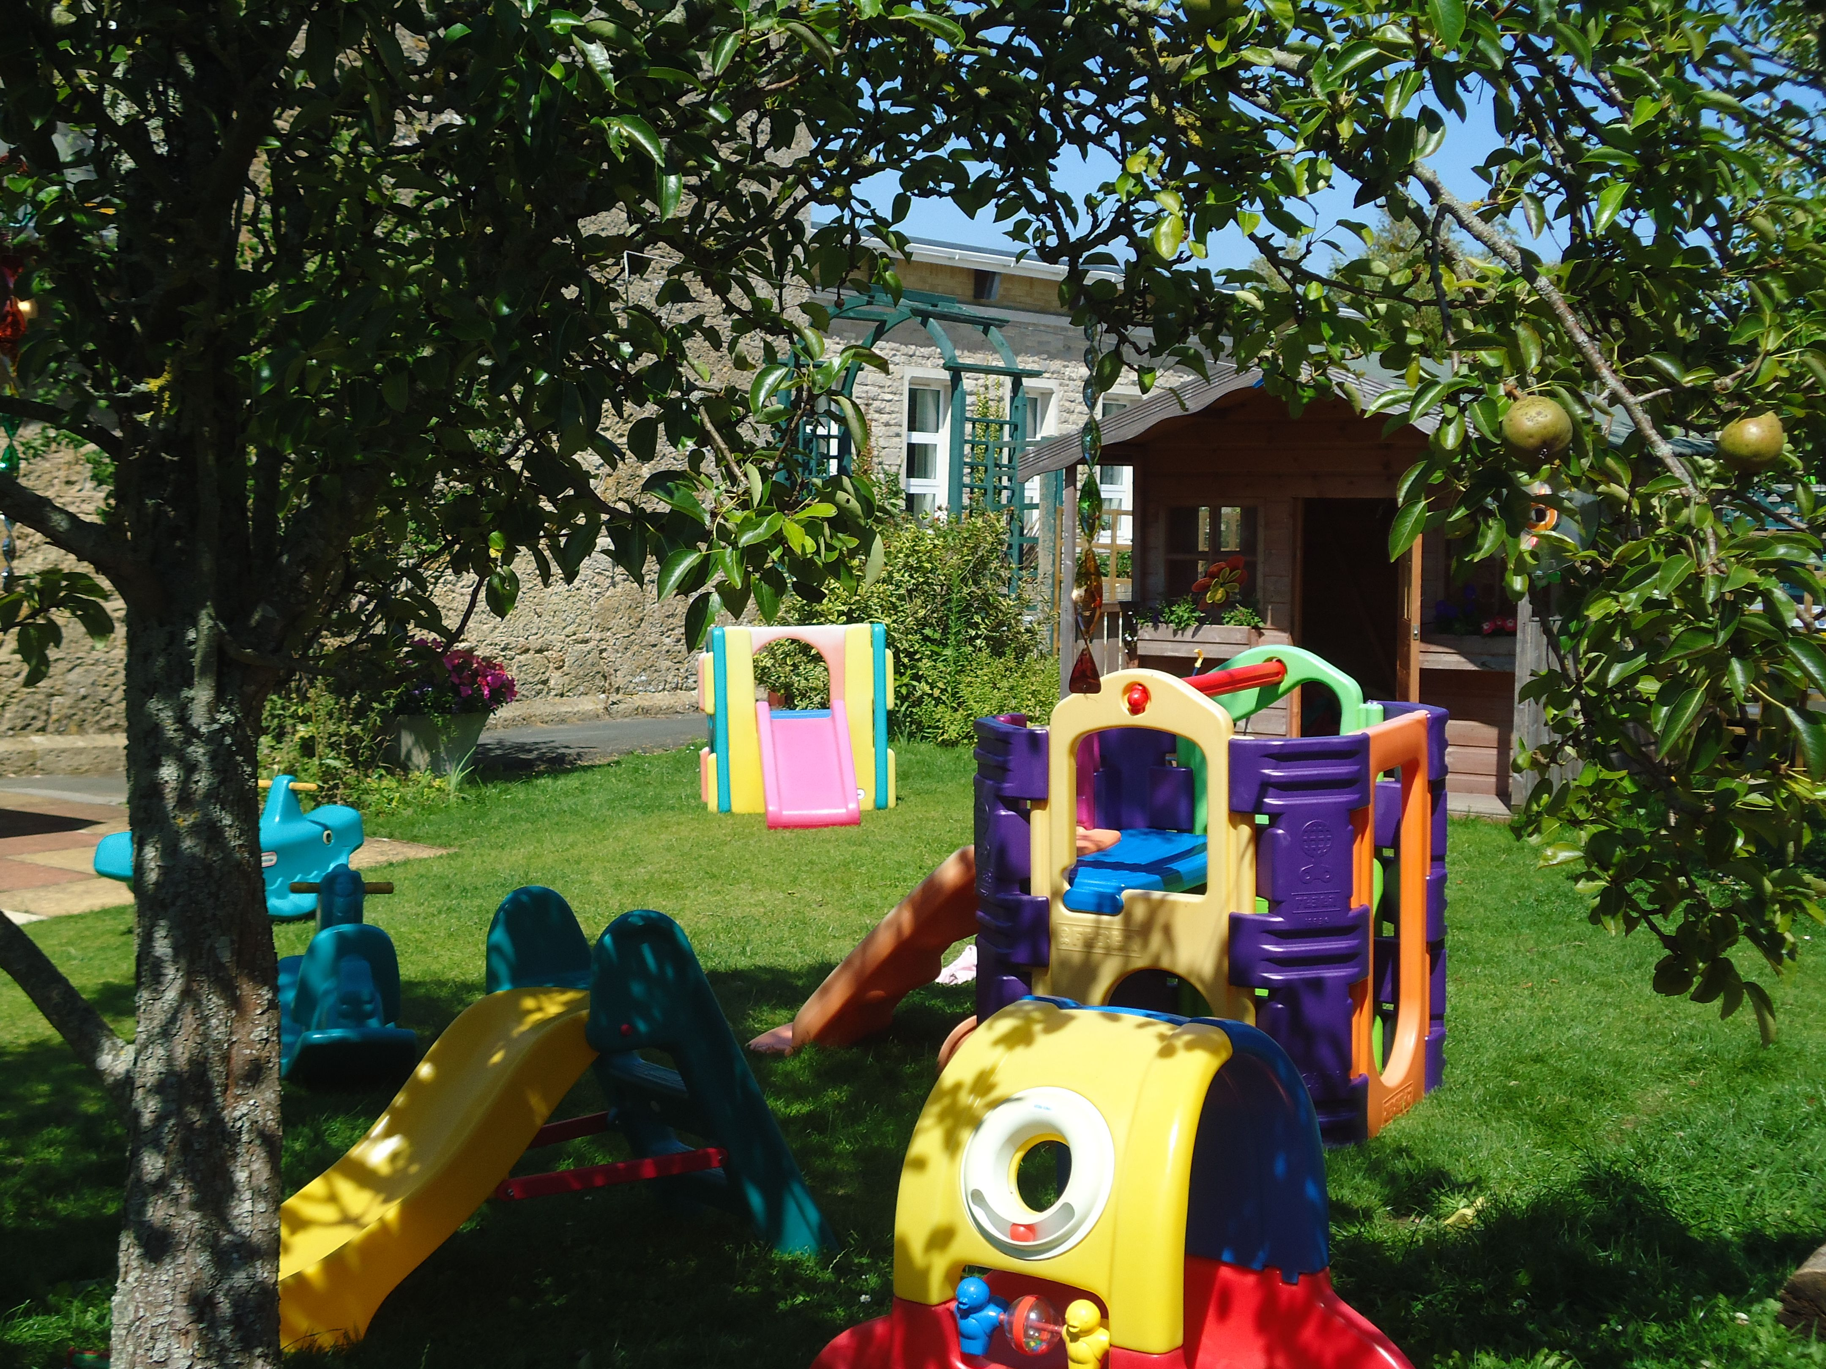

The Foundation Stage room prides itself on working closely to EYFS guidance regarding enabling environments. The practitioners continually reflect upon the space and resources available both indoors and outdoors to promote a positive learning environment for the unique individuals at Little Explorers. The resources are readily accessible to the children, one example of how this is promoted is through the use of photographs and pictures .The room itself incorporates the areas required such ‘The Book Corner, The Music Area, Construction Area, The Writing Table, ICT, Small World, The Home Corner, Role Play, Problem Solving Reasoning and Numeracy, Art and Creative,’ to name but a few. The room is tailored daily to suit children’s current observed interests with practitioners offering a balance of activities and complete a daily sheet to inform parents and carers of these indoor and outdoor activities. Free flow access to the outside area is promoted, to allow children the choice of playing indoors, outdoors, or both. The Foundation Stage room is fortunate enough to have the use of an outdoor space which is often shared with the school’s Reception Class. Children’s positive behaviour is reinforced through praise from practitioners, and an example is the use of a friendship tree. A leaf is added when an act of kindness, caring, helpfulness or effort is recognised. All of this adds to the development and encouragement of the children’s self esteem and wellbeing.

Learning and Development - Children develop and learn in different ways and at different rates and all areas of Learning and Development are equally important and inter-connected (EYFS, 2012).

The following information has been taken from the Early Years Foundation Stage document, 2012. All children are different and to reflect this age ranges have been overlapped in the EYFS to create broad developmental phases. This emphasis’s that each child’s progress is individual to them and that different children develop at different rates.

Birth to 11 months
During this period, young children’s physical development is very rapid and they gain increasing control of their muscles. They also develop skills in moving their hands, feet, limbs and head, quickly becoming mobile and able to handle and manipulate objects. They are learning from the moment of birth. Even before their first words they find out a lot about language by hearing people talking, and are especially interested when it involves themselves and their daily lives. Sensitive care giving, which responds to children’s growing understanding and emotional needs, helps to build secure attachments to special people such as parents, family members or carers. Regular, though flexible, routines help young children to gain a sense of order in the world and to anticipate events. A wide variety of experience, which involves all the senses, encourages learning and an interest in the environment.

8 – 20 months
As children become mobile new opportunities for exploration and exercise open up. A safe and interesting environment, with age-appropriate resources, helps children to develop curiosity, coordination and physical abilities. This is a time when children can start to learn the beginnings of self-control and how to relate to other people. In this period children can be encouraged to develop their social and mental skills by people to whom they have a positive attachment. Building on their communication skills, children now begin to develop a sense of self and are more able to express their needs and feelings. Alongside non-verbal communication children learn a few simple words for everyday things and people. With encouragement and plenty of interaction with carers, children’s communication skills grow and their vocabulary expands very rapidly during this period.

16 – 26 months
Children in this phase are usually full of energy and need careful support to use it well. Growing physical strengths and skills mean that children need active times for exercise, and quiet times for calmer activities. Playing with other children is an important new area for learning. This helps children to better understand other people’s thoughts and feelings, and to learn how to cooperate with others. Exploration and simple self-help builds a sense of self-confidence. Children are also learning about boundaries and how to handle frustration. Play with toys that come apart and fit together encourages problem solving and simple planning. Pretend play helps children to learn about a range of possibilities. Adults are an important source of security and comfort.

22 – 36 months
Children’s fine motor skills continue to develop and they enjoy making marks, using a variety of materials, looking at picture books and listening to stories, important steps in literacy. Self-help and independence soon emerge if adults support and encourage children in areas such as eating, dressing and toileting. Praise for new achievements helps to build their self-esteem. In this phase, children’s language is developing rapidly and many are beginning to put sentences together. Joining in conversations with children is an important way for children to learn new things and to begin to think about past, present and future. Developing physical skills mean that children can now usually walk, climb and run, and join in active play with other children. This is an important time for learning about dangers and safe limits.

30 – 50 months
An increased interest in joint play such as make-believe, construction and games helps children to learn the important social skills of sharing and cooperating. Children also learn more about helping adults in everyday activities and finding a balance between independence and complying with the wishes of others. Children still need the comfort and security of special people. Close, warm relationships with carers form the basis for much learning, such as encouraging children to make healthy choices in food and exercise. At this stage children are becoming more aware of their place in a community. Literacy and numeracy can develop rapidly with the support of a wide range of interesting materials and activities. Children’s language is now much more complex, as many become adept at using longer sentences. Conversations with adults become a more important source of information, guidance and reassurance.

40 – 60+ months
During this period children are now building a stronger sense of their own identity and their place in a wider world. Children are learning to recognise the importance of social rules and customs, to show understanding and tolerance of others, and to learn how to be more controlled in their own behaviour. Learning and playing in small groups helps to foster the development of social skills. Children now become better able to plan and undertake more challenging activities with a wider range of materials for making and doing. In this phase children learn effectively in shared
activities with more able peers and adults. Literacy and problem solving, reasoning and numeracy skills continue to develop. Children’s developing understanding of cause and effect is encouraged by the introduction of a wider variety of equipment, media and technologies.

The following information is taken from EYFS development matters:
The Early Years Foundation Stage consists of 3 prime areas and 4 specific areas of learning and development. The 3 prime areas of learning and development are:
- ,
- Personal, Social and Emotional Development
- Physical Development
- Communication and Language
The prime areas begin to develop quickly in response to relationships and experiences, and run through and support learning in all other areas. The prime areas continue to be fundamental throughout the EYFS.

The 4 specific areas of learning and development are:
- Literacy
- Mathematics
- Understanding of the World
- Expressive Arts and Design
The specific areas include essential skills and knowledge. They grow out of the prime areas, and provide important contexts for learning.

Characteristics of effective learning are playing and exploring, active learning, and creating and thinking critically.

Play, exploration, and active learning,
The Early Years Foundation Stage states that children’s play reflects their wide ranging and varied interests and preoccupations. In their play children learn at their highest level. Play with peers is important for children’s development. Children learn best through physical and mental challenges. Active learning involves other people, objects, ideas and events that engage and involve children for sustained periods.

In the Birth to Three room, we base our activities and experiences on the babies and young children’s current interests. We provide for each child’s learning journey and their interests through personalised activities and experiences, incorporating adding extra accessible resources to extend their play and adult support. These activities and experiences promote the prime areas of learning and development. For example if a child is interested in farms we provide activities like farm animals in the sand or soil play, tyre printing and welly boot painting.

In the Foundation Stage room there is a backdrop to learning which is changed each half term which incorporates children’s interests and surrounding environments i.e. seasons. The backdrop to learning includes a variety of planned activities - for indoors, outdoors, adult initiated and child initiated, to support all areas of learning and development. Each child has an individual learning journey which is tailored to meet their interests and needs. These are produced each term by the key person and parents/carers working in cohesion to support the child’s learning and development.
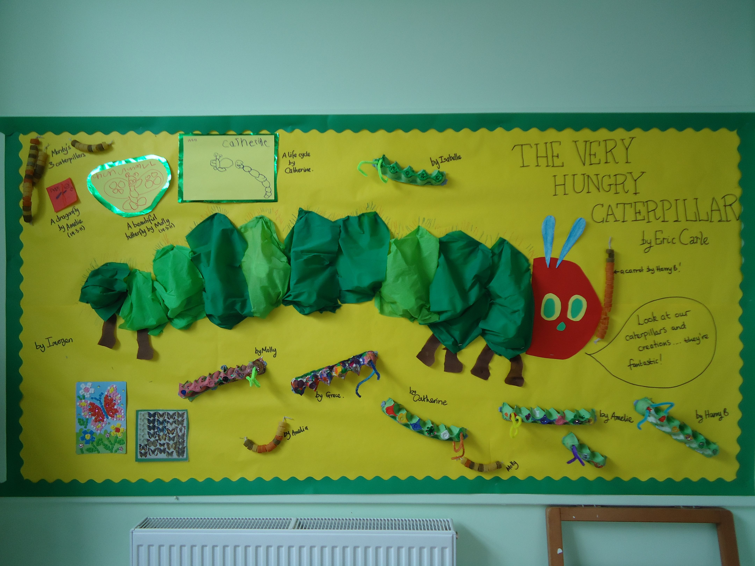

In both rooms every child has a unique child’s learning and development folder. These folders contain an all about me booklet, routines (for children under three years old), a parent/carer feedback sheet to record any comments and termly meetings, a unique child development record with supportive observations, photos and children’s work i.e drawings. These files are available to parents / carers daily who are able to take them home to look through and record any comments. We actively encourage parents / carers to contribute to these folders by sharing information about their child with us and add their observations of their child on yellow observation sheet which is available to access independently in both rooms. We offer termly meetings with parents/carers to discuss their child’s achievements and/or any concerns, and their learning journeys.

Parental involvement
Parents are children’s first and most enduring educators. When parents/carers and practitioners work together in early years settings, the results have a positive impact on children’s development and learning. Therefore we strive to work with parents and carers, this is achieved through the close relationships established via the key person approach. Parents/carers are encouraged to write down any of their child’s achievements or interests they have shown at home. This promotes shared record keeping and the observations are included in their child’s learning and development folder. Parents/carers have access to their child’s learning and development folders and key persons offer formal meetings each term to discuss children’s achievements. We encourage parents/carers to play an active part in the setting, whether joining the committee or contributing their skills, knowledge and interests to the activities of the setting. Additionally we operate an open door policy where parents/carers are welcome to come and discuss any valuable ideas or concerns at any time.

Healthy Eating /Lifestyles
All practitioners hold a current Food and Hygiene Certificate. The kitchen in the setting has been awarded 5/5 stars by Environmental Health department of the Isle of Wight Council. One of our practitioners regularly attends the school’s ‘Change for Life’ group to provide positive links between the two and share ideas regarding healthy eating and lifestyles which recently produced handouts for parents that included ideas for a healthy packed lunch, winter warmer recipes, ideas for incorporating vegetables into meals and a booklet on Chinese New Year recipes. The group recognises the importance of children’s self image and well being as well as diet and exercise.

The Birth to Three room requests that parents and carers send in a piece of fruit daily to be eaten at midmorning fruit time. Birth to Three practitioners recognise that babies and toddlers routines vary, regarding milk feeds, weaning, sleep patterns, and strive to follow them and promote a home from home environment.
Both rooms request that children attending our setting have their own named water bottle. Packed lunches can be brought to the setting as can home cooked meals/meals to be reheated in the facilities provided. School dinners are also available and Chartwells supply a menu which works on a three week turnaround.
The Foundation Stage room incorporates a ‘fruit bar’ where two of the children are chosen daily to serve their peers, therefore promoting social and emotional development as well as communication skills. Milk and water are also offered at this time of the day, a water jug and cups are available throughout the day or children can bring their own named water bottles.
The Foundation Stage room has opportunity to use the school hall during the week promoting physical development through parachute games, use of equipment benches and mats. Both rooms promote physical development daily inside and out, some examples of resources to support this area of learning are soft play shapes, ride ons, scooters and trikes, bats and balls.
Little Explorers request that parents and carers provide their child/children with appropriate clothing for the season, as outdoor play ‘whatever the weather’ is a daily occurrence. Children naturally have the instinct to explore their environments so wellies, older clothes, spare clothing can help to make the experience more fulfilling. During the warmer months we ask that sun cream is applied before arrival at the setting and named sunhats are provided, practitioners will re-apply cream to the very young or those that need assistance but promote independence where possible.
Settling your child in at the setting
We want children to feel safe, stimulated and happy in the setting and to feel secure and comfortable with staff. We also want parents to have confidence in both their children’s well being and their role as active partners with the setting.

We aim to make the setting a welcoming place where children settle quickly and easily because consideration has been given to the individual needs and circumstances of children and their families. We allocate a key person to each child and his/her family before she/he starts to attend; the key person welcomes and looks after the child and his/her parents at the child’s first session and during the settling-in process. We can arrange a home visit by the person who will be the child’s key person, to ensure all relevant information about the child can be made known. When a child starts to attend, we explain the process of settling-in with his/her parents and jointly decide on the best way to help the child to settle into the setting. We have an expectation that the parent, carer or close relative, will stay for most of the session during the first week, gradually taking time away from their child, increasing this as and when the child is able to cope. Younger children will take longer to settle in, as will children who have not previously spent time away from home. Children who have had had a period of absence may also need their parent to be on hand to re-settle them. When parents leave, we ask them to say goodbye to their child and explain that they will be coming back, and when. We do not believe that leaving a child to cry will help them to settle any quicker. We believe that a child’s distress will prevent them from learning and gaining the best from the setting. We reserve the right not to accept a child into the setting without a parent or carer if the child finds it distressing to be left. This is especially the case with very young children. We make clear to families from the outset that they will be welcome and supported in the setting for as long as it takes to settle their child there. For further information or advice please speak to Linda or Becky.

Partnership with the School
Being on the school site has enabled Little Explorers to develop strong links especially between the pre-school and reception class, which helps support both children, parents, key practitioners and teachers. Experiencing a happy and positive introduction into school life with what is hoped to be seamless transition.

We have weekly visits into reception class to join in with play activities, song and story time, this has proved to be a valuable way of enabling our children to become familiar with the school, the classroom environment, daily routines and the teaching team working within the school foundation stage.

Our rising four sessions towards the end of the summer term offer more opportunities for both children and parents to become more familiar with the reception class for two mornings, before a whole school move up day, where the children will have lunch in the school hall.

Our foundation stage and reception class regularly join together for special events throughout the year such as sports days, school fun days, Easter events, bring a parent to breakfast, Chinese new year, Diwali, Teddy bears picnic and much more, which enables the pre-school to offer a ongoing carousel of events throughout your child’s time in our pre-school.

School Travel Plan
The main school has a working travel plan in place for which we at Little Explorers are a part of. The aim is to cut congestion, ensure safety for all children and promote an awareness of environmental impact. We respectfully ask that you become familiar with the school travel plan and adhere to it at all times.

Policies
The setting’s policies help us to ensure that we provide high quality services to both the children who attend the setting and their parents/carers. Our policies have been adapted from the policies of the Pre-school Learning Alliance and fulfil the welfare requirements of the Early Years Foundation Stage. Please find attached at the end of this prospectus the following policies: safeguarding children policy, sickness policy, equality and diversity policy, special educational needs policy and charging policy. If you would like to see further polices there is a folder containing the setting’s polices and procedures in the reception or please ask a member of staff. These policies and procedures can also be obtained by email request.

The management of Shalfleet 'Little Explorers
A management committee – whose members are elected by the parents/carers of the children who attend the setting – manages the setting. The elections take place at the setting’s Annual General Meeting that is held in September each year. The committee is responsible for:
- managing the setting’s finances;
- employing and managing the staff;
- making sure that the setting has, and works to, policies which help to maintain high quality service;
- making sure that the setting works in partnership with the children’s parents/carers.
A full copy of the committee’s roles and responsibilities can be obtained on request.
The Annual General Meeting is open to the parents/carers of all the children who attend the setting. It is their forum for looking back over the previous year’s activities and shaping the coming year’s activities.

The current Shalfleet 'Little Explorers' Committee members are:

Chair Mr. Bruce Shilton
Treasurer Miss Gemma Hobbins
Secretary Ms. Emma Greenwood
Parent Representative Mrs Laura Homes
Governor Representative Mrs Carla Bradshaw
Primary School Representative Mrs Laura Homes
Health & Safety Officer Mrs. Linda Harrop
School Head Teacher Ms. Elizabeth Grainger

Charity Commission No. 1077551

Booking places and payment of fees

From April 2018 the fees will be:
- 0 to 2 years old - £4.70 per hour
- 2 to 3 years old - £4.05 per hour
- 3 to 4 years old - £3.75 per hour
- Breakfast club - £2.50
- After-school club - £3.75 per hour
- Holiday club - £3.75 per hour

These are reviewed yearly usually during January. Advanced payments of one month for hours booked. Any additional hours to be paid, on receipt of statement. Any additional hours to be paid at the end of the week/day taken in. Credit terms of seven days will apply and a written request for payment will be made. Fees must still be paid if children are absent. For more information regarding fees please see the charging policy attached at the back of this prospectus. If your child has to be absent over a long period, talk to Mrs. Linda Harrop - the team leader or Mr.Bruce Shilton – the committee chair. For your child to keep her/his place at the setting you must pay the fees or we must receive nursery education funding for your child.

Funded children
From the term after their 3rd birthday children are eligible for funding for 15 hours a week.
Children born on or between Are eligible for funding from
1st April and 31st August 1stSeptember following their 3rd birthday
1st September and 31st December 1st January following their 3rd birthday
1st January and 31st March 1st April following their 3rd birthday

Please note NEG funding allocation will vary throughout the year due to government terms and conditions. Please see the administrator for further details.

If you have any further questions or queries please do not hesitate to contact the setting to discuss these with Linda or Becky. If you would like to visit the setting for the first time or to arrange a second visit please feel free to contact the setting to arrange this. We look forward to hearing from you.

Application to join Shalfleet ‘Little Explorers’

Name of child …………………………………………………………………………………………………….

Name(s) and addresses(es) of parent(s)/carer(s)

……………………………………………………………………..……………………………………………………….
…………………………………………………..….… ………….……………………………………………………….
………………………………………………………... ………….……………………………………………………….
………………………………………………………… ……………..…………….…………………………………….
Postcode …………………………………… Telephone ……….…………………………………….

Child’s Date of Birth ………………………………………

I would like my child to attend Shalfleet ‘Little Explorers’ on:

MONDAY Hours……………………………………………… TUESDAY Hours……………………………………….
WEDNESDAY Hours………………………………………. THURSDAY Hours……………………………………
FRIDAY Hours…………………………………………

I would like my child to start: * as soon as possible

*from (date) …………………………………………………………..
*Please delete whichever is not applicable.

If I find that I no longer need the place, I will inform the setting as soon as possible.

Name of parent / carer…………………………………………………………………………………

Signature of parent / carer…………………………………………………………………

How did you hear about our setting (please tick):-
Recommendation □ Website □ Internet □
Health Visitor □ Children’s Centre □ FIZ □
Advertising □ Please state which ……………………………………………………………………………….
Other □ Please state which ………………………………………………………………………………

Date received (office use only):…………………………………………………..……………………

